2021 Housing Forum: Key Takeaways
Presented by BizFed Institute & Milken Institute
September 17, 2021

Much gratitude to the more than 170 leaders, thinkers, and innovators who registered to attend our 2021 Housing Forum on Friday, September 17. Our goal in co-hosting the interactive, workshop-style forum alongside our partners at the Milken Institute was to convene the brightest minds in our orbit to deconstruct problems and craft actionable solutions. We sought to highlight a wide array of perspectives from leaders with diverse areas of expertise and lived experiences, representing various constituencies and sectors. I don’t think it’s a stretch to say we all emerged from this Housing Forum better connected, equipped, and motivated to tackle every facet of California’s housing shortage crisis: production, affordability, homelessness, homeownership, resident selection, and resiliency, to name a few.

Kevin Harbour
BizFed Institute President

Kevin Klowden, executive director of the Milken Institute’s California Center, kicked off the program with an in-depth review of our Flash Housing Poll. 71 housing industry professionals shared their insights on hot-button issues and potential solutions. The results were telling but not surprising: the vast majority of respondents pointed to inefficiency as a root cause of the housing crisis and identified expediency-focused solutions as a step in the right direction.

- 55% of respondents said reducing delays (whether through CEQA reforms or changes in building permitting processes) would help increase housing production.
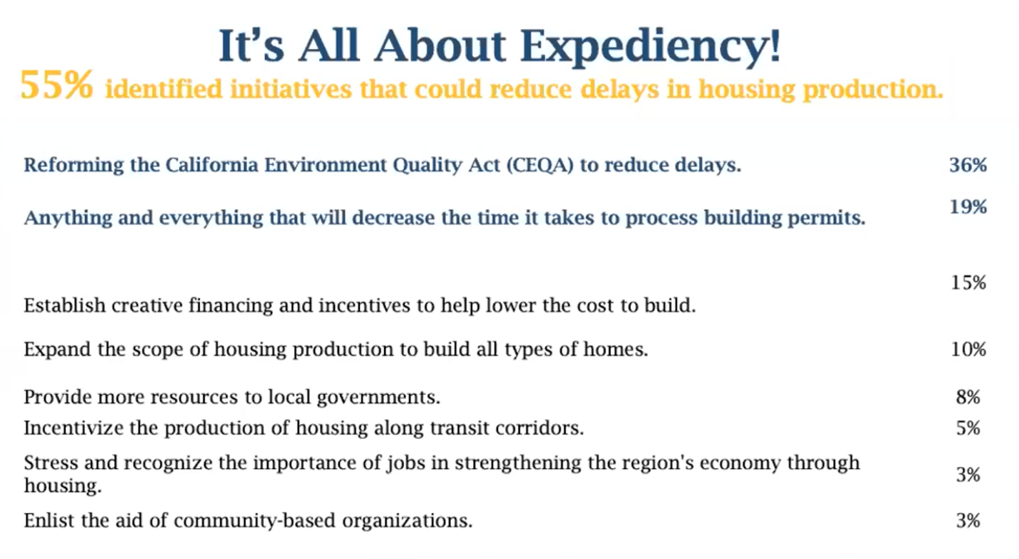

- 79% of respondents said reducing delays that result in excessive building costs should be a top priority.

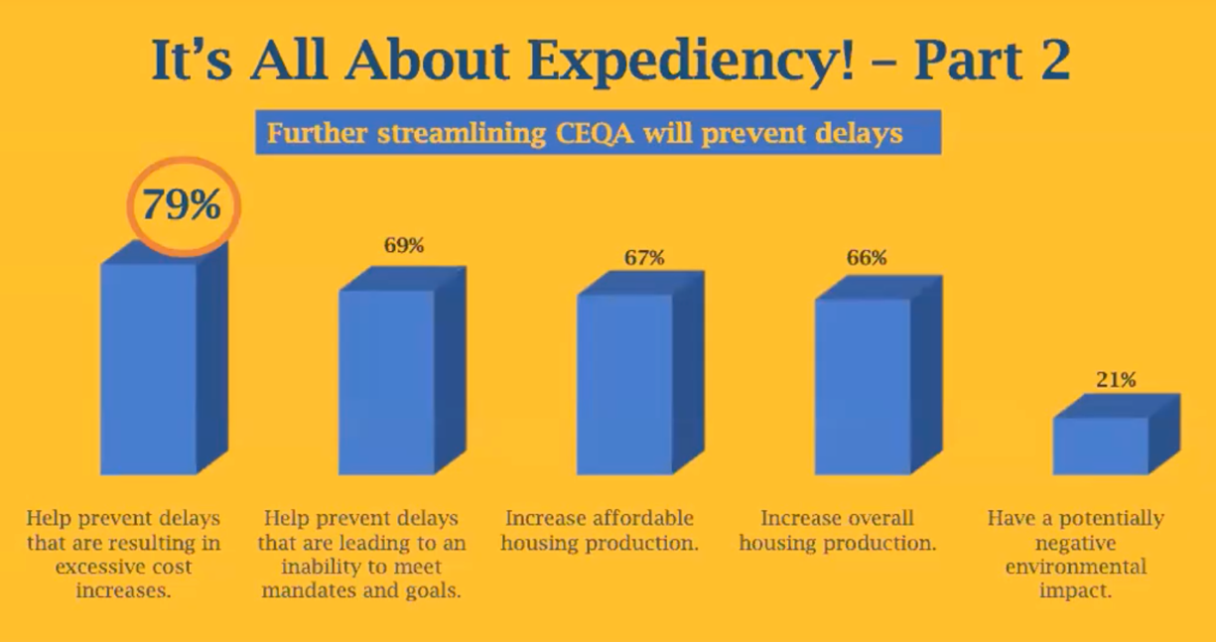

- The third and final portion of the poll saw a wide range of competing preferences in the area of housing affordability/accessibility. 25% of respondents prioritized repurposing commercial real estate into workforce housing, while 22% chose new construction and 20% called for increased focus on increasing affordable housing for people earning less than 80% of the Area Median Income (AMI).
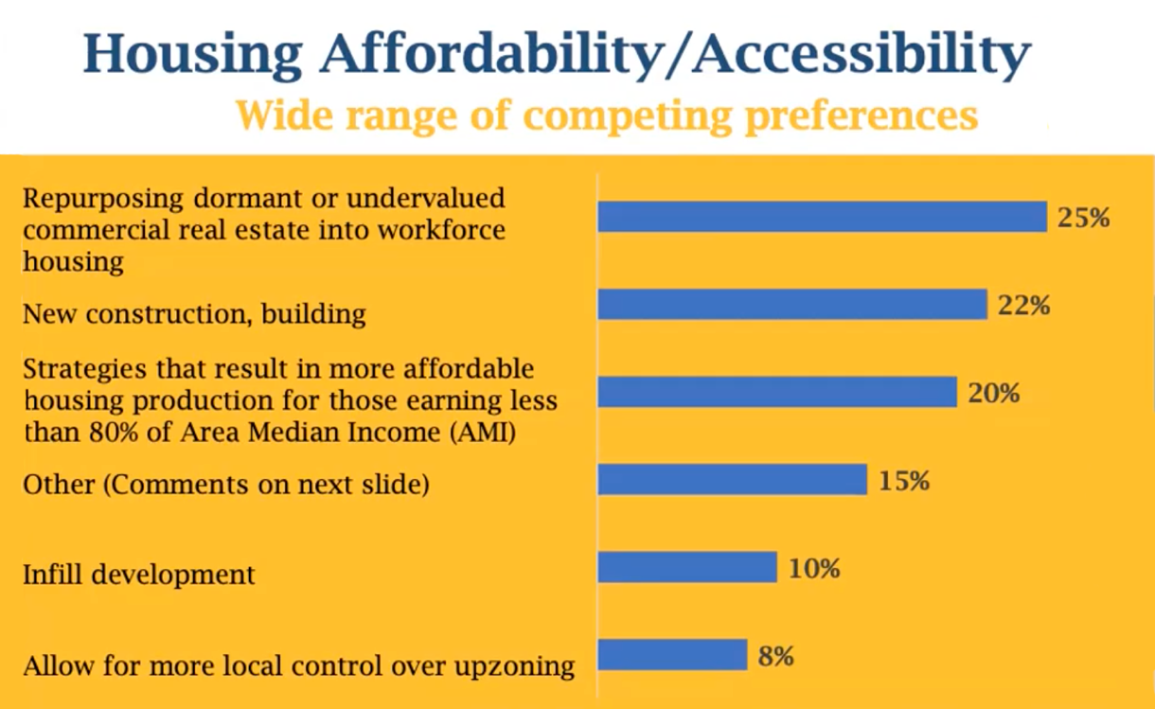

"Efficiency is something we have taken out of the system here in California,” Klowden said. “Ultimately, it really is about time. It’s about the ability to execute and get things done.”

California Senate Majority Leader Bob Hertzberg seized the reins, bringing his signature energy to the program and enthusiastically laying out the framework of the plan he plans to roll out in January aimed at creating new paths to homeownership without further burdening taxpayers. We “cannot tax our way out” of California’s housing crisis, he warned. Instead, Sen. Hertzberg urged investors to help “flip the script” and empower lower income renters to become homeowners.

Creating a $25 billion fund that acts as a silent second on properties and allows people to pay back loans with a rate of return when they sell their homes can produce up to 250,000 new units, the senate majority leader said, increasing production, stimulating infill development, and letting more people accumulate wealth by moving away from renting. Hertzberg touted his plan as a realistic, workable model that protects the California dream by zeroing in on several key issues.

“It doesn’t solve every housing problem,” he said. “What happens in government is everyone tells you everything that’s wrong. Just go fix one issue.”

PANEL #1: Protecting & Repurposing Affordable Housing

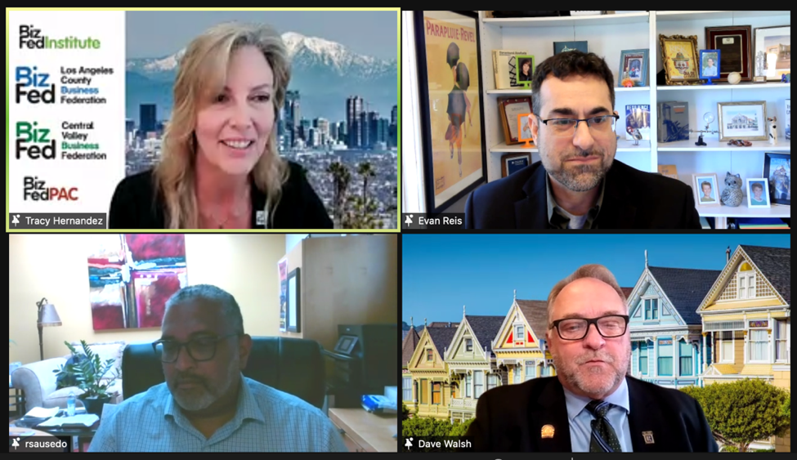

BizFed Founding CEO Tracy Hernandez opened the forum’s first interactive roundtable by highlighting BizFed Institute Chair Jonathan Parfrey’s bold leadership. Parfrey, the CEO of Climate Resolve, has led numerous summits in recent months that challenge people with different visions to find tangible solutions together. The dynamic group of panelists in this section of the program displayed the same resolve to tackle problems from various angles. Each panelist came prepared to share one bright idea related to protecting and repurposing affordable housing.

Evan Reis, co-founder and executive director of the U.S. Resiliency Council, stressed the importance of investing in the resiliency of existing properties that are not up to code, rather than merely thinking about ways to create new housing. Approximately 100,000 buildings with 1 million units across California that house upwards of 2.5 million people are not seismically safe, according to research shared by Reis. These are largely “soft-story structures”: older, wood-framed buildings that are typically 2-3 stories with parking underneath. People who live in these buildings may not have housing after a major earthquake. Investing in comprehensive resiliency now is a low-cost, high-priority action item.

“You don’t ever want to speak after Bob Hertzberg because he’s put all the big ideas out there already,” joked Robert Sausedo, president and CEO of Community Build, Inc. Nevertheless, he captured the attention of the Zoom gallery with his call to reimagine both CEQA and resident selection processes, and his quotable quip about the state of California’s emergency: “The term ‘affordable housing’ is an oxymoron.” One of the culprits? The way CEQA has been weaponized, Sausedo explained. The threat of a lawsuit or lengthy environmental review is often enough to stop or delay much-needed housing projects. Instead of protecting the environment, CEQA is exacerbating the housing crisis and must be “reimagined immediately,” Sausedo said. He offered a second bright idea targeting the unfairness permitted too often by “fair” housing laws: rethink how residents are selected for available homes. Developers often survey communities to glean housing needs before commencing projects – but then end up producing units that community members cannot afford or are not approved to live in.

Dave Walsh, 2021 president of the California Association of Realtors, also applauded Sen. Hertzberg’s passion for innovative housing solutions and matched the Senate Majority Leader’s enthusiasm when he launched into his bright idea: convert excess commercial space into sorely needed residential space of all types with the support of partners at all levels of government. Office buildings, hotels, shopping malls, and retail sites – often in desirable neighborhoods with access to transit options, and with sewer, utilities, and parking infrastructure already in place – sit vacant across California. “Wouldn’t it make sense to convert this space into homes? We think so,” said Walsh, noting that the coronavirus pandemic permanently changed working and shopping habits, significantly decreasing the need for commercial buildings. Working with Congress to create tax incentives for repurposing these sites into affordable and workforce housing is key to getting this bold yet practical idea off the ground.

PANEL #2: Public Policies to Increase Housing Production of All Forms

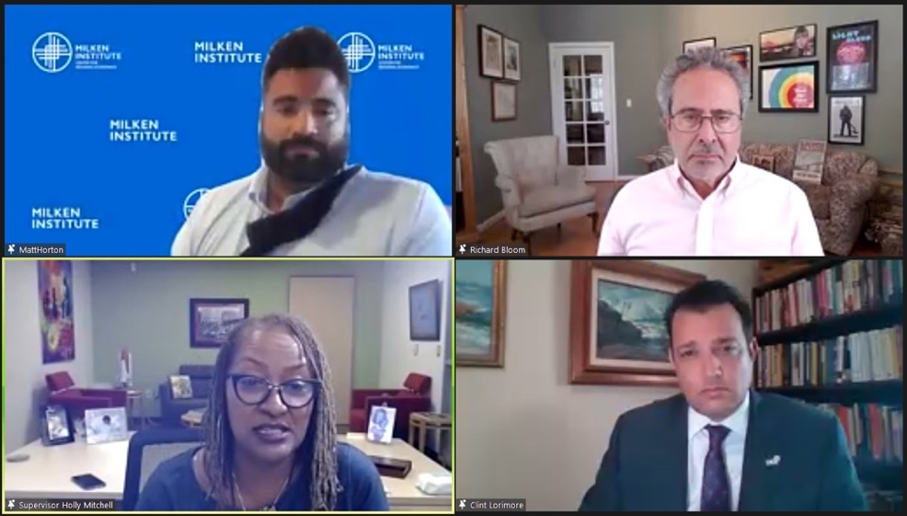

Matt Horton, director of the Milken Institute’s Center for Regional Economics, opened the forum’s second interactive roundtable by reviewing a playbook of policy recommendations and next steps developed by the 2020 Regional Housing Working Group. He touched upon the effects of California’s housing supply issues on economic mobility and pointed to the need for renewed focus on workforce and affordable housing – the “missing middle” in our housing inventory. Los Angeles County remains, unsurprisingly, his recommended geographic area of focus.
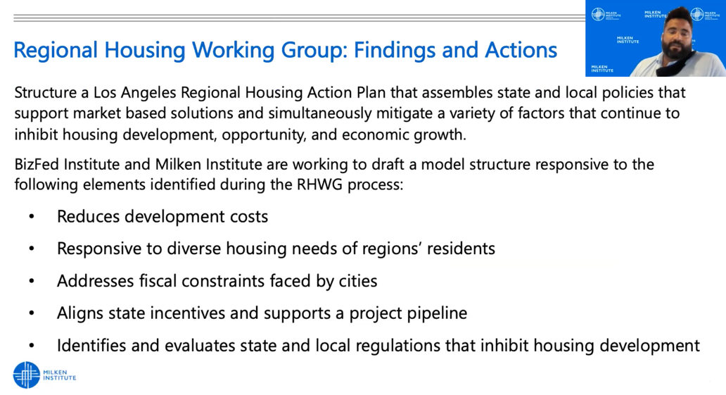

Asm. Richard Bloom, who represents California’s 50th Assembly District, called out the irony of local governments not having the resources to follow mandates imposed on them. His proposed fix: encourage policymakers and stakeholders to work with municipalities to ensure they have the ability to implement new housing policies – and give cities “breathing room” to do so. In some cases, support may be needed in the form of technical assistance, Bloom said, noting even westside communities in his district were “stretched thin” by the implementation of certain policies during the coronavirus pandemic. Funding should be made available to support local governments’ capacity to execute on housing solutions. “We did that in the environmental realm,” Bloom said.

Sup. Holly Mitchell, who represents LA County’s Second Supervisorial District, cautioned against attempting to address California’s housing shortage emergency “in a vacuum.” Too often, she said, county-level officials discuss proposed solutions only with each other, while state-level officials engage in parallel conversations in their own bubble – with disappointing results. Government alone cannot solve the housing crisis, she added. Her overarching bright idea: deep analysis of what we build, for whom, and where with all stakeholders. Charging ahead with shortsighted plans that fail to simultaneously address questions of what, whom, and where can lead to the appearance of short-term success (i.e. housing 212 people a day) but ultimately a depletion of resources with no real progress (i.e. 212 people finding themselves unhoused again each day). Mitchell urged policymakers and the private sector to come together. “No matter what approach we choose, some segment of the population will hate it. We have to just lock arms, have courage, and jump,” she said.

Clint Lorimore shared his unique dual perspective as mayor pro tem of Eastvale and president of the Southern California Association of Governments. His bright idea was built around a catchphrase first coined during a BizFed Board of Directors meeting: more tools, less rules. “The only way to address [the housing crisis] is to build our way out of it,” Lorimore said. Mandates coming out of Sacramento without the necessary tools to help cities follow them will not increase housing production at the local level, he warned. SCAG, which he described as a “pro-housing agency,” is especially concerned with legislation that attacks local control and takes valuable redevelopment dollars away from cities. Lorimore applauded Asm. Bloom’s call for “breathing space” at the local level, as well as initiatives like AB 101, which secured $250 million for cities to help facilitate planning.

PANEL #3: Housing Inhibitors & Playbook Reflections

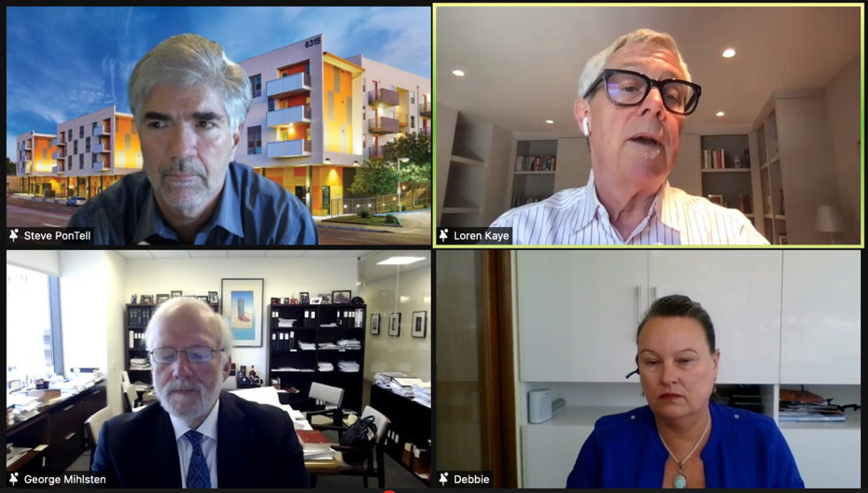

Steve PonTell, president and CEO of National Community Renaissance, challenged each speaker on his panel to add value to the conversation by sharing something positive: a success story, trend, or development to inject hope into the crisis situation. He applauded his panelists for arriving armed with “observations from the street” and encouraged all attendees to think of themselves not as casual observers of the housing crisis, but as active, frontline problem-solvers: “Because we got ourselves into this situation, we can get ourselves out of this situation. This is no external force at work forcing us into our housing shortage.” He recommended broadening future discussions around housing production inhibitors by including faith-based, healthcare, and educational perspectives.

George Mihlsten, partner at Latham & Watkins LLP, cited the advancement of the 23-unit FivePoint Valencia Newhall project in Santa Clarita (following 17 years of planning and multiple rounds of litigation) as a sign of progress. He swiftly followed up by pinpointing what he saw as the fundamental problem underlying the housing shortage crisis: an illogical state finance structure that disincentivizes affordable housing production while encouraging projects such as shopping centers and auto malls that generate significant sales tax revenue for local jurisdictions. LA County’s newly adopted 1% art fee typifies the problem we’re facing, he said, calling on leaders to rethink the economics of housing production from a local government standpoint. The cost of producing housing should not exceed the ability of the local population to pay for that housing. Mihlsten also shouted out the trend away from legislation that implicates housing in the interface between urban and forest lands, but cautioned against quietly adopted policies “operating below the surface” that drive up costs, such as a new rule requiring licenses for rooftop solar panel installation. Thank you for joining us on your birthday, George!

Loren Kaye, president of the California Foundation for Commerce & Education, pointed to “fewer bad ideas in Sacramento that are advancing to policy” as a “good trend,” and called on legislators and housing industry stakeholders to “do no harm” while pushing solutions to ramp up production and drive down building costs. The dial may even be moving toward improvement in Sacramento, he said. His bright idea: focus on coalition building to expand perspectives and resources, with increased focus on groups with “less of a voice but as much of a stake” in the ongoing housing debate.

Deborah La Franchi, founder and CEO of SDS Capital Group, touted her own work with Los Angeles-based RMG Housing as a positive model for rapid affordable housing production. SDS Capital Group’s $130 million supportive housing initiative has reduced the amount of time for permanent housing projects from 5-7 years to 24 months. The model funds only one developer and does not rely on taxpayer money for land or construction, allowing SDS to underwrite and close on 97% of capital needed within 60 days. La Franchi’s team has funded 6 projects to date and plans to fund 30 statewide, with approximately 22 located in Los Angeles. Her bright idea: expedite permitting and inspection processes, which she identified as the costliest step in producing new housing units. “We could do 50% more units if we could get through the City of LA faster. But because we’re not using public subsidy, we can’t get the expediting for our permanent supportive housing that other developers are able to get,” La Franchi explained. She also called for a local task force focused on permanent supportive housing to work collaboratively in pinpointing the top 10 housing production impediments. She concluded her hope-inspiring narrative with a note of urgency. Tax revenue will plummet if we don’t get more people off the streets soon, pushing more Californians to leave the Golden State, she warned.

Jonathan Parfrey, BizFed Institute Chair and CEO of Climate Resolve, closed the program with a more succinct recap of the bright ideas outlined above. His big-picture reminder about what must happen for us to execute those ideas should guide our next steps as we, hopefully, continue bridging silos to find common ground.

“This conversation is taking place amidst a background of an enormous budget surplus and allocation of dollars this fiscal year,” Parfrey said. “Although those dollars are much appreciated, we need to figure out a way to have an ongoing stream of support from the government assisting the private sector.”

